Self-Reflection Work Sheet
Ask yourself deep questions when self-reflecting.

Label your emotions.
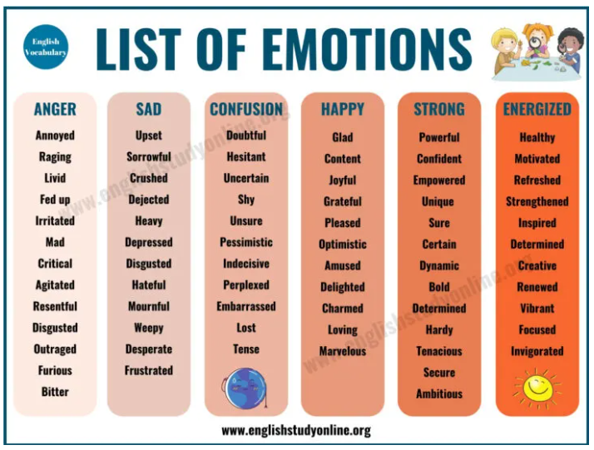
Create Goals for yourself and check in once per month. How are you doing?
Career
Spiritual
Emotional
Mental Health

Practice Gratitude. Take notes on what you are grateful for.
Daily
Monthly

Write down what is going well.

Write down things that didn’t go well and how to improve them.

